Manage Panopto and MS Teams Recordings
For Teaching Staff

Contents

1. Introduction 2
2. How to set up the Panopto integration in MS Teams? 2
3. How to record your MS Teams Video 3
4. Locate your recordings in Panopto. 3
4.1 Locate your recorded video via the Sulis Panopto Tool 3
4.2 Locate your recorded Video via the Panopto website 5
5. Edit the captions on your recordings in Panopto. 6
5.1- How to Add Captions to your recordings. 6
6. Share your recording 7
7. Share your recording with the Public 8
8. Conclusion 9

Table of Figures

Figure 1: How to add an 'app' in MS Teams 2
Figure 2: Panopto App Authentication 3
Figure 3:Location of the 'Start recording' button in MS Teams 4
Figure 4: Location of the Panopto tool in Sulis 5
Figure 5 Sample recordings 5
Figure 6: Location of videos from the Panopto website 6
Figure 7: Location of the 'Edit' button for captions. 7
Figure 8: Edit Captions in Panopto 7
Figure 9: Location of Captions playback button in Panopto 8
Figure 10: Location of 'Settings' button in Panopto 8
Figure 11: Move the video out of personal folder into the module folder. 9

Introduction.
Panopto is recording software that can be used for recording lectures or presentations, uploading an existing video, or embedding videos with content into your Sulis or Moodle site. The Panopto integration for MS Teams is now available. This integration allows MS Teams meeting recordings to be automatically uploaded into Panopto. This new integration should make it easier for you to locate your MS Teams recordings in Panopto, edit them, add captions, and share your recordings with your students.
These instructions are designed for teaching staff who are currently using MS Teams for teaching purposes and wish to share a copy of the recording via Panopto.

How To Set Up the Panopto Integration In MS Teams.
In this section, you will locate the ‘Panopto’ application inside MS Teams and link it to your UL account. Once this is done, future recordings made in MS Teams will be stored in your private Panopto folder as well as One Drive.
Detailed instructions for setting up the Panopto integration are located here –
Link to Panopto support website: How to enable the MS Teams Integration
Please take a few minutes to follow along with the steps in the guide linked above.
In summary, the steps to set up the Panopto app in MS Teams are:
- Open your MS Teams Desktop app on your computer.
- Under APPS on the left hand panel, press the 3 ellipses (3 dots), select ‘More Apps’ and find the Panopto icon (see image below).
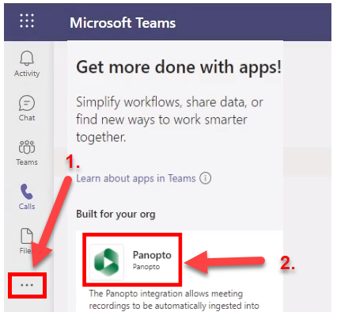
Figure 1: how to add an 'app' in MS Teams
- Click on the Panopto icon, Choose ‘Add’.

- Press ‘Authenticate’ to (see image below) follow the authentication steps listed on the Panopto support website. (You will be asked to sign into your account, and follow the instructions to add the Panopto app to MS Teams).
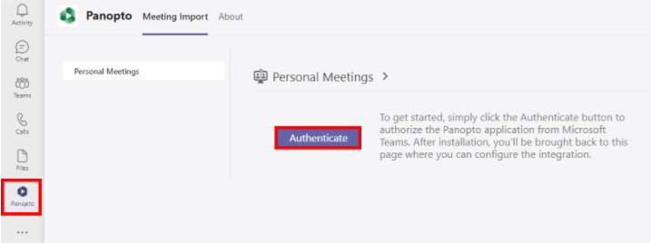
Figure 2: Panopto App Authentication
- Once the Panopto App is added to MS Teams, you can decide which of your Teams meetings will be recorded into Panopto. These future recordings are stored inside the “Meeting recordings” folder, under “My Folder”. More details on how to locate the ‘Meeting recordings’ folder in Panopto are in section 4 of this guide.
- Whilst the default location for your recordings is the ‘Meeting recordings’ folder, you may want a specific Teams recording to get imported to a different folder. In this case please use the Meeting-Folder Mappings to manage that. Details are on the Panopto support website.
Note:
Creator permissions in Panopto are needed to use this application. All instructors who click on the Panopto tool in Sulis/Moodle will be automatically assigned creator permissions in Panopto. If you have never used the Panopto tool in Sulis/Moodle, and do not have creator permissions, please log a call with ITD. See web link: How to log a call with ITD.
We recommend that you that upload your videos to the “Meeting recording” folder as this allows you to upload your recordings to a private folder. Subsequent, you can verify the video, make the required edits and then make it available to your students.
Meetings will be available in Panopto in approximately 40-60 minutes after the meeting has ended.

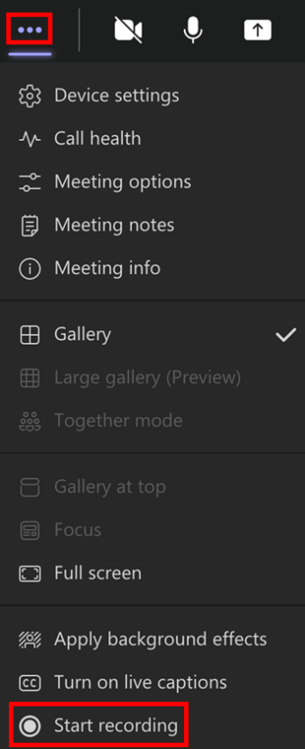
How To Record Your Live Classroom session in MS Teams.
Figure 3:Location of the 'Start recording' button in MS Teams
If you have never recorded a video on MS Teams, please watch the video guide below by Jess Beeley.
Watch: 2 min Video explaining how to record with Microsoft Teams
- As outlined in the video above, log into MS Teams, upload your files for the presentation and turn on your webcam. When ready, select the three dots on the MS Teams toolbar and then select the Start recording button (see Figure opposite)

- When you have finished the presentation, press the same button again to stop the recording.

- Allow MS Teams up to 30 minutes to prepare the recording for you.

Locate Your Recordings In Panopto or One Drive.
There are 3 ways you can locate your recording –
- Locate your recordings from the Panopto tool within Sulis (see step 4.1),
- Locate the video recording from the Panopto website (see step 4.2)
- Locate the recording within One Drive (see step 4.3).

4.1 Locate your recorded video via the Sulis Panopto Tool
By default, all your MS Teams recordings will be stored in the “Meeting Recordings” folder in Panopto, and this is a subfolder located under your personal “My Folder”.
To locate these recordings via Sulis
- Log into Sulis.
- Open a course site and select the Panopto tool from the left-hand menu of your Sulis site, see ‘No. 1’ in the image below for details.
- Select the ‘down arrow’ to locate the Meeting Recordings in My Folder. See ‘No. 2’ of the image below for details.
- Click into the “Meeting Recordings” folder to display your MS Teams recordings. See ‘No. 3’ of the image below for details.

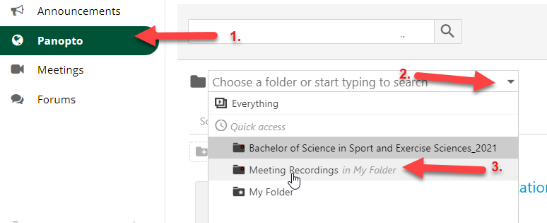
Figure 4: Location of the Panopto tool in Sulis
The image below shows an example of a video stored inside the ‘Meetings Recordings’ folder.
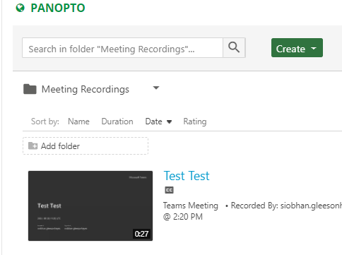
Figure 5 Sample recordings
If you would like to share your video without further edits, skip to step 6 of this instructions document, which will outline how to share your video with students.

Locate your recorded Video via the Panopto website
If you do not have access to Sulis, you can locate your video via the UL Panopto website.
- Log into Panopto at https://ulcampus.cloud.panopto.eu.
- Type in your UL username and password to log in,
- Locate ‘My Folder’ on the left hand panel and the ‘Meetings Recordings’ folder (see image below, No. 1).
- Inside ‘Meetings Recordings tab’ you will then see your recorded videos, (see image below, No. 2, No. 3).
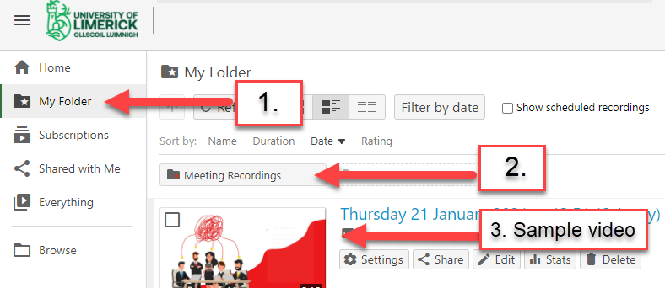
Figure 6: Location of videos from the Panopto website

4.3 Locate your recorded video in One Drive online
A copy of your recording is also visible in One Drive. To locate and share recordings from One Drive, please view the relevant guide ‘How to manage your recordings in One Drive’ linked here. Only use One Drive if you want to share with viewers who do not have access to Sulis or Moodle, or with viewers outside of the classroom, or outside of UL. One Drive does not give the option to provide video captions for your viewers.

Edit The Captions in Your Recordings in Panopto.
Now that you have located your recording in Panopto, you can edit it inside your personal ‘Meeting recordings’ folder before sharing with others. You can crop the start and end as well as numerous other edits like adding captions and quizzes.

5.1- How to Add Captions to your recordings.

- Use the steps outlined above to locate your recording via Sulis, Moodle, or Panopto online.
- Select the Edit button which is underneath the video title. This will allow you to add your captions to the recording (see image below).
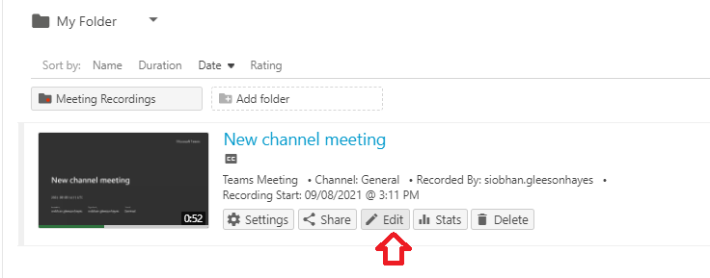
Figure 7: Location of the 'Edit' button for captions.

- On the next screen, select the Captions button on the left hand menu (see image below).
- Edit the captions where necessary,
- Click the Apply button, at the bottom of the ‘Captions’ page.
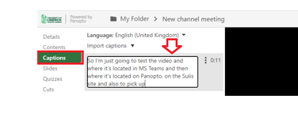
Figure 8: Edit Captions in Panopto

Students will then have the option to turn on captions by clicking the show captions button when they play the recording on their Sulis site. The captions button is indicated in the image below.
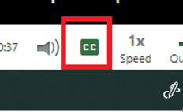
Figure 9: Location of Captions playback button in Panopto

Share Your Recording With Students.
By default, your recordings will be stored in the “Recorded Meetings” folder, which is a subfolder of your private “My Folder” in Panopto.
Once you have located the video, (using the earlier part of this guide), you will be ready to share it.
In order for students to view these recordings, you must move the video out of your personal ‘My folder’ as outlined below.
- Access the video using the earlier steps in this guide.
- Select the ‘Settings’ button underneath the relevant video name, see image below.
Figure 10: Location of 'Settings' button in Panopto

- On the next screen, press the ‘Overview’ tab, see image below No. 1.
- To change current location out of ‘My folder’, press the ‘Edit’ text. See the image below, No.2.
- You will now move the video to a folder with the relevant module code in the title. For example, if you are an instructor on module EN4026, then press ‘Edit’ to move the video to a destination folder which has the module code (EN4026) in its title. See the image below, No.2. Tip: Make sure that you have also chosen the current semester.
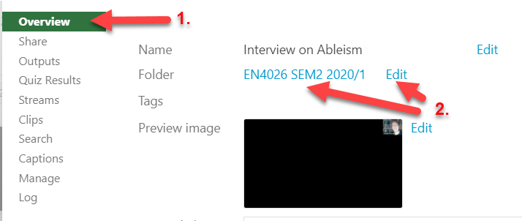
Figure 11: Move the video out of personal folder into the module folder.

Watch video: See this 5 minute overview of “how to move your recording from your personal folder to another Sulis site” by Niall Collins.

How To Enable Public Access to a Recording.
The share steps in this guide are designed to cater to teachers who have access to Sulis or Moodle sites for teaching. In some cases however, you may want to share a video to others who do not have access to Sulis or Moodle to view it. In this case, you have several options.
1: A copy of your recording is also visible in One Drive. To locate and share recordings from One Drive, please view the relevant guide ‘How to manage your recordings in One Drive’ linked here. You can choose to share to ‘Anyone with the link’, which opens the recording to the public.
2: In some cases, for example (marketing videos, tutorial videos, or Open Day videos), you will need to provide public access to your video whilst also retaining the full functionality of Panopto for captions and embed options. In this case, please log a call with ITD, who will provide your department with a ‘public access’ folder on Panopto. See web link: How to log a call with ITD.

Conclusion.
In this guide, you learnt how to optimise the Panopto App in MS teams, how to locate the recorded video in your Panopto personal folder, and how to share that video to your class. In addition, you learnt how to give ‘public access’ to your video if relevant.

